**GREEN GUARDIANS**

**GREEN SCHOOLS**

Green schools are educational institutions designed to be environmentally friendly and sustainable. They focus on reducing their ecological footprint while promoting health and well-being for students and staff. Here are some key features of green schools:

1. **Energy Efficiency**: Use of renewable energy sources like solar panels, energy-efficient lighting, and HVAC systems to reduce energy consumption.
2. **Sustainable Materials**: Construction and renovation using eco-friendly materials, such as recycled or sustainably sourced products.
3. **Water Conservation**: Implementation of water-saving fixtures, rainwater harvesting systems, and landscaping that requires minimal irrigation.
4. **Indoor Air Quality**: Use of non-toxic materials and proper ventilation to ensure a healthy indoor environment.
5. **Waste Reduction**: Programs for recycling, composting, and reducing waste through education and initiatives.
6. **Environmental Education**: Curriculum that includes sustainability topics, encouraging students to engage with and understand environmental issues.
7. **Biodiversity**: Incorporating green spaces, gardens, and natural habitats to support local wildlife and enhance biodiversity.

Green schools aim to create a healthier learning environment while teaching students the importance of sustainability. Would you like to know more about a specific aspect of green schools?

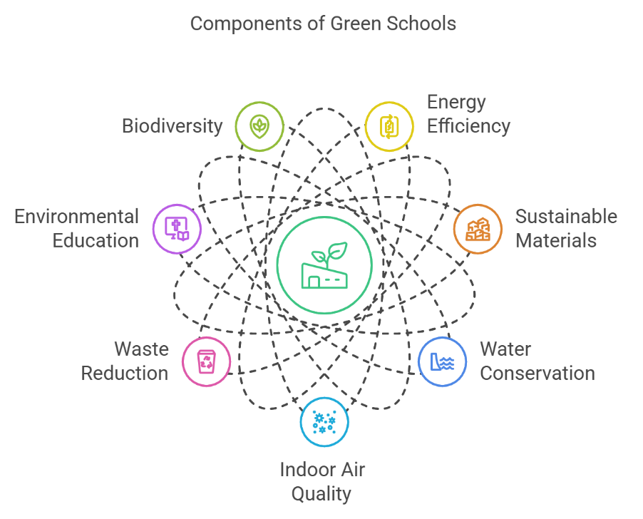

**GREEN ENERGY**

Green energy refers to energy that is generated from renewable, sustainable sources that have a minimal impact on the environment. Here are some key types and concepts related to green energy:

1. **Solar Energy**:
   * Generated from sunlight using solar panels.
   * Can be used for electricity (photovoltaic systems) or heating (solar thermal systems).
2. **Wind Energy**:
   * Produced by harnessing wind through turbines.
   * Wind farms can be located on land or offshore.
3. **Hydropower**:
   * Generated from the movement of water, typically through dams or river systems.
   * It converts kinetic energy from flowing water into electricity.
4. **Biomass**:
   * Organic materials (like plant and animal waste) are used to produce energy.
   * Can be burned directly for heat or converted into biofuels.
5. **Geothermal Energy**:
   * Utilizes heat from beneath the Earth's surface.
   * Can be used for heating or to generate electricity.
6. **Tidal and Wave Energy**:
   * Generated from the movement of tides and ocean waves.
   * Still in developmental stages but holds potential for renewable energy.

**Benefits of Green Energy:**

* **Environmental Impact**: Reduces greenhouse gas emissions and pollution.
* **Sustainability**: Renewable sources are abundant and can be replenished naturally.
* **Energy Independence**: Reduces reliance on fossil fuels and enhances energy security.
* **Economic Growth**: Creates jobs in the renewable energy sector.

Green energy plays a crucial role in combating climate change and promoting a sustainable future. If you want to dive deeper into any specific type of green energy or its applications, let me know!

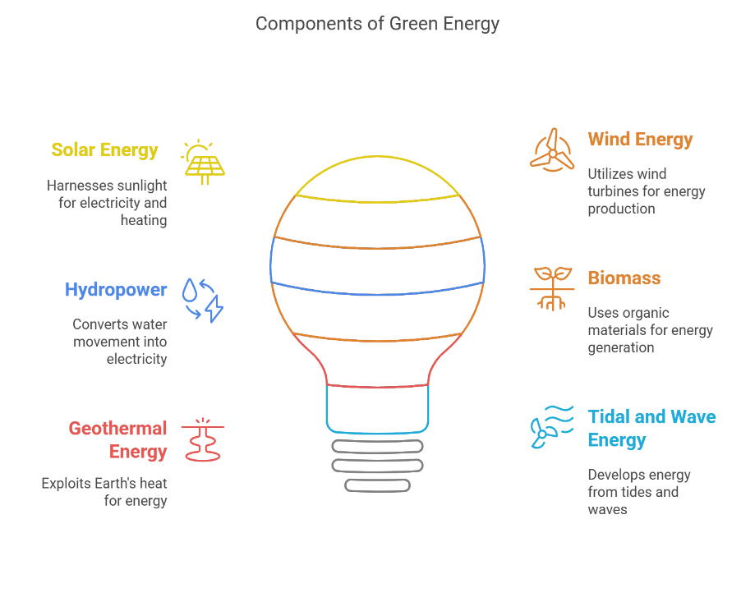

**WASTE MANAGEMENT**

Waste management refers to the collection, transportation, processing, recycling, and disposal of waste materials. It aims to reduce the impact of waste on human health and the environment. Here are the key components and strategies involved in effective waste management:

**1. Types of Waste:**

* Municipal Solid Waste (MSW): Everyday items discarded by the public, such as food scraps, packaging, and household items.
* Hazardous Waste: Waste that poses a risk to health or the environment, including chemicals, batteries, and medical waste.
* Industrial Waste: Waste generated from manufacturing processes, which can include both hazardous and non-hazardous materials.
* E-waste: Discarded electronic devices, which can contain harmful substances.

**2. Waste Management Hierarchy:**

The waste management hierarchy prioritizes strategies to manage waste effectively:

1. Reduce: Minimizing waste generation at the source by using fewer materials and choosing sustainable options.
2. Reuse: Finding new uses for items instead of discarding them, extending their life cycle.
3. Recycle: Processing materials to create new products, reducing the need for raw materials and energy.
4. Recover: Extracting energy from waste through methods like incineration or anaerobic digestion.
5. Dispose: Safely landfilling or incinerating waste that cannot be reused or recycled.

**3. Waste Management Strategies:**

* Composting: Converting organic waste (like food scraps and yard waste) into nutrient-rich compost for gardening and landscaping.
* Recycling Programs: Implementing community programs to collect and process recyclable materials, such as paper, plastics, and metals.
* Waste-to-Energy: Converting non-recyclable waste into usable energy through combustion or other technologies.
* Education and Awareness: Promoting responsible waste management practices among individuals and businesses to encourage participation in recycling and reduction efforts.

**4. Benefits of Effective Waste Management:**

* Environmental Protection: Reduces pollution, conserves natural resources, and minimizes the impact on ecosystems.
* Public Health: Proper waste management helps prevent disease and health hazards associated with waste accumulation.
* Economic Savings: Reducing waste can lead to cost savings in disposal and resource management, while recycling can create jobs and stimulate the economy.

Effective waste management is crucial for sustainable development and protecting the environment. If you want to explore specific waste management practices or case studies, just let me know!

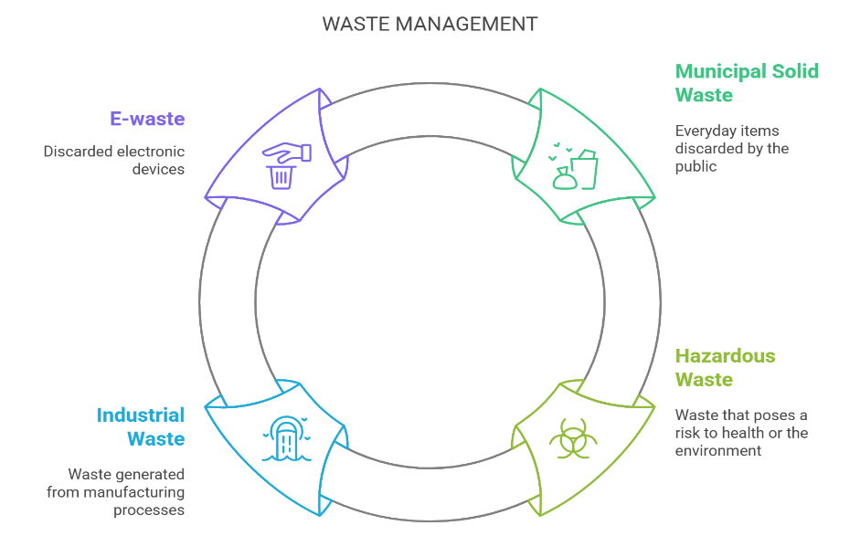

**CLIMATE AWARENESS**

Climate awareness refers to the understanding and recognition of climate change, its causes, impacts, and the actions needed to address it. Here are some key aspects of climate awareness:

1. Understanding Climate Change:
   * Recognizing that climate change is primarily driven by human activities, such as burning fossil fuels, deforestation, and industrial processes.
   * Awareness of the greenhouse effect, where gases like CO2 and methane trap heat in the atmosphere**.**
2. **Impacts of Climate Change:**
   * Increased temperatures, extreme weather events (hurricanes, droughts, floods), and rising sea levels.
   * Effects on ecosystems, biodiversity, agriculture, and human health**.**
3. **Importance of Mitigation and Adaptation:**
   * Mitigation: Efforts to reduce or prevent the emission of greenhouse gases (e.g., transitioning to renewable energy, improving energy efficiency).
   * Adaptation: Adjusting practices, processes, and structures to minimize damage from climate impacts (e.g., building flood defenses, developing drought-resistant crops).
4. **Role of Education and Advocacy:**
   * Promoting climate education in schools and communities to raise awareness and encourage action.
   * Supporting policies and initiatives that aim to combat climate change at local, national, and global levels.
5. **Individual Actions:**
   * Encouraging sustainable practices like reducing waste, conserving energy, using public transport, and supporting eco-friendly products.
6. **Global Initiatives:**
   * Participation in international agreements like the Paris Agreement, which aims to limit global warming to well below 2 degrees Celsius.

Climate awareness is crucial for fostering a collective response to climate change and ensuring a sustainable future. If you want to explore specific initiatives or ways to promote climate awareness, just let me know!

Can you explain the relationship between climate change and biodiversity loss?

The relationship between climate change and biodiversity loss is significant and interconnected. Here’s a breakdown of how they influence each other:

**1. Impact of Climate Change on Biodiversity:**

* Habitat Alteration: Changes in temperature and precipitation patterns can alter habitats, making them unsuitable for many species. For example, rising sea levels can inundate coastal habitats, while increased temperatures can shift ecosystems like forests and grasslands.
* Species Migration: As climates change, many species are forced to migrate to cooler areas or higher altitudes. This can lead to overcrowding in suitable habitats and increased competition for resources.
* Phenological Changes: Climate change can disrupt the timing of natural events (like flowering or breeding), leading to mismatches in food availability and reproductive cycles. For instance, if plants bloom earlier due to warmer temperatures, pollinators may not be present when they need to be.
* Increased Extinction Risk: Species that cannot adapt quickly enough to changing conditions or migrate to suitable habitats face a higher risk of extinction. This is particularly true for specialized species with limited ranges.

**2. Impact of Biodiversity Loss on Climate Change:**

* Ecosystem Services: Biodiversity contributes to ecosystem services that help regulate the climate, such as carbon sequestration, water purification, and soil fertility. Loss of biodiversity can weaken these services, making ecosystems less resilient to climate change.
* Feedback Loops: The loss of biodiversity can create feedback loops that exacerbate climate change. For example, deforestation reduces the number of trees that can absorb CO2, leading to higher atmospheric carbon levels and further warming.
* Reduced Resilience: Ecosystems with high biodiversity are generally more resilient to environmental changes. When biodiversity is lost, ecosystems may become more vulnerable to climate impacts, leading to further degradation.

**Conclusion**

The relationship between climate change and biodiversity loss is a cycle where each exacerbates the other. Protecting biodiversity is essential for mitigating climate change and ensuring ecosystems can adapt to changing conditions. Conversely, addressing climate change is crucial for preserving biodiversity and maintaining healthy ecosystems.

If you want to explore specific examples or solutions related to this relationship, let me know!

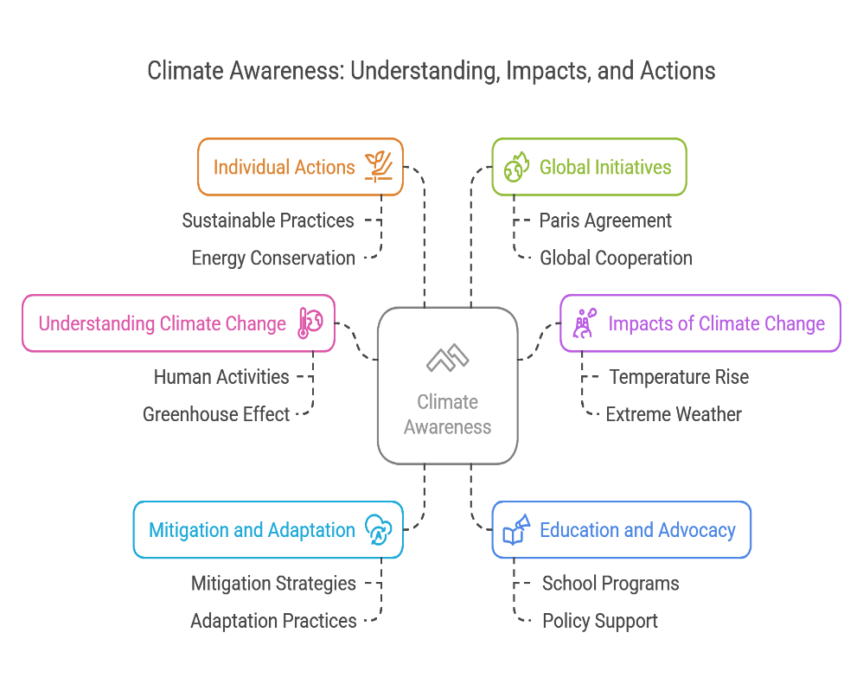

**PLASTIC CONSCIENCE**

Plastic conscience" refers to an awareness of the environmental impact caused by plastic production, consumption, and waste. It is a concept that encourages individuals, businesses, and societies to be more mindful of how plastic affects the planet, wildlife, and human health. People with a "plastic conscience" feel the responsibility to reduce their reliance on single-use plastics, support sustainable alternatives, and minimize their contribution to plastic pollution.

Here are some key aspects of plastic conscience:

**1. Awareness of Plastic's Impact**

* **Environmental Pollution**: Plastic takes hundreds of years to degrade, and much of it ends up in oceans, rivers, and landfills. This has devastating effects on ecosystems, especially marine life, where animals often mistake plastic for food or become entangled in it.
* **Health Concerns**: Many plastics contain harmful chemicals, such as BPA (bisphenol A) and phthalates, which can leach into food and beverages, posing potential health risks.
* **Climate Change**: The production of plastic is resource-intensive and contributes to greenhouse gas emissions. The extraction of fossil fuels for plastic manufacturing adds to climate change.

**2. Reducing Single-Use Plastics**

* **Opting for Reusables**: Using reusable bags, water bottles, and containers is a significant step in reducing plastic consumption. Reusable items reduce the need for single-use plastic packaging.
* **Choosing Eco-Friendly Packaging**: Many companies are shifting toward sustainable packaging made from materials like paper, glass, or biodegradable plastics.
* **Refusing Plastic Straws and Utensils**: With a growing number of restaurants and businesses opting for alternatives, people are encouraged to say no to plastic straws, cutlery, and other one-time-use items.

**3. Supporting Recycling and Circular Economy**

* **Recycling Programs**: Plastic-conscious individuals and communities promote better recycling practices to ensure that plastics are properly sorted and repurposed, rather than ending up in landfills.
* **Upcycling**: Some people engage in upcycling, which involves repurposing old plastic items into new products, thus extending the life cycle of plastic.

**4. Advocating for Policy Change**

* **Legislation**: Many plastic-conscious individuals support policies that limit plastic production and waste. This includes bans on single-use plastics, stricter recycling laws, and incentives for companies to create biodegradable or recyclable products.
* **Corporate Responsibility**: There's increasing pressure on companies to adopt eco-friendly practices, use sustainable materials, and be transparent about their environmental impact.

**5. Personal Responsibility**

* **Mindful Consumption**: The concept of plastic conscience encourages individuals to make thoughtful choices when buying products. This includes considering packaging, opting for products that are free from plastic or come in recyclable packaging, and supporting companies with green practices.
* **Lifestyle Shifts**: Many people who embrace plastic conscience choose to buy secondhand, support local businesses that use sustainable packaging, and find creative ways to reduce plastic in their day-to-day lives.

**6. Global Movement**

* **Activism and Advocacy**: Organizations like Greenpeace, Surfrider Foundation, and Plastic Pollution Coalition are at the forefront of global efforts to reduce plastic waste. Many activists organize beach cleanups, educational campaigns, and push for stricter regulations.
* **Global Bans**: Some countries and regions, such as the European Union and several U.S. states, have implemented bans on single-use plastic bags, plastic straws, and other disposable plastic items.

**7. Alternative Materials**

* **Biodegradable Plastics**: Some companies are developing plastics made from renewable resources like cornstarch or algae that break down more easily in the environment. However, even these alternatives need proper disposal systems to prevent environmental harm.
* **Edible Plastics**: There are also innovations in edible packaging, such as seaweed-based wraps, that aim to replace conventional plastic packaging.

**How Can You Cultivate a Plastic Conscience?**

* **Education**: Stay informed about the impacts of plastic on the environment and health.
* **Sustainable Choices**: opt for reusable items, choose products with minimal plastic packaging, and support businesses that prioritize sustainability.
* **Waste Reduction**: Recycle responsibly, avoid single-use plastics, and compost when possible.
* **Advocacy**: Support policies that promote plastic reduction and participate in local clean-up initiatives or awareness campaigns.

The plastic conscience movement is about fostering a mindset where people actively seek to reduce their environmental impact by reducing plastic use and encouraging sustainable practices.

Would you like to explore specific ways to reduce plastic usage, or are you interested in learning more about global movements addressing plastic pollution? Let me know!

